AWS VPC Creation Guide

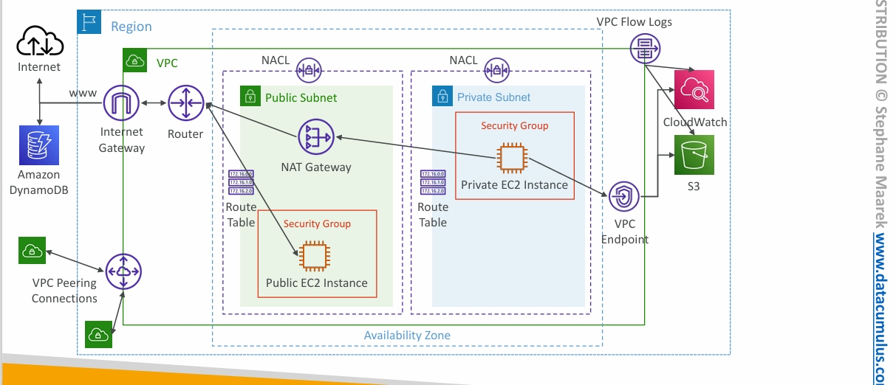

1. Introduction to VPC
Amazon Virtual Private Cloud (VPC) allows you to launch AWS resources in a logically isolated virtual network. You can customize the network configuration, including IP address ranges, subnets, route tables, and internet connectivity.

2. Steps to Create a VPC

Step 1: Create a VPC
- Sign in to the AWS Management Console.
- Navigate to the VPC Dashboard.
- Click Create VPC.
- Enter the following details:
  - Name tag: MyCustomVPC
  - IPv4 CIDR block: 10.0.0.0/16
  - Tenancy: Default
- Click Create VPC.

Step 2: Create Public and Private Subnets
- Navigate to the Subnets section.
- Click Create Subnet.
- Select the VPC you just created.
- For the public subnet:
  - Name tag: PublicSubnet
  - CIDR block: 10.0.1.0/24
  - Availability Zone: Choose any AZ (e.g., us-east-1a)
  - Click Create Subnet
- Repeat the process for the private subnet:
  - Name tag: PrivateSubnet
  - CIDR block: 10.0.2.0/24
  - Availability Zone: Same or different AZ (e.g., us-east-1b)

Step 3: Create and Attach an Internet Gateway (IGW)
- Navigate to the Internet Gateways section.
- Click Create Internet Gateway.
- Enter Name tag: MyIGW.
- Click Create Internet Gateway.
- Select the IGW and click Attach to VPC.
- Choose MyCustomVPC and click Attach.

Step 4: Configure the Route Tables

Public Route Table
- Go to the Route Tables section.
- Click Create Route Table.
- Enter Name tag: PublicRouteTable.
- Select MyCustomVPC and click Create.
- Select the PublicRouteTable and go to the Routes tab.
- Click Edit Routes > Add Route.
  - Destination: 0.0.0.0/0
  - Target: Select Internet Gateway (MyIGW)
- Click Save routes.
- Associate the public subnet with this route table:
  - Go to the Subnet Associations tab.
  - Click Edit Subnet Associations.
  - Select PublicSubnet and click Save.

Step 5: Create a NAT Gateway for Private Subnet
- Go to the Elastic IPs section and allocate a new EIP.
- Go to the NAT Gateways section and click Create NAT Gateway.
- Select PublicSubnet and assign the allocated Elastic IP.
- Click Create NAT Gateway.
- Go back to Route Tables and create a new Private Route Table:
  - Name tag: PrivateRouteTable
  - VPC: MyCustomVPC
  - Click Create.
- Select the PrivateRouteTable and go to the Routes tab.
- Click Edit Routes > Add Route.
  - Destination: 0.0.0.0/0
  - Target: Select NAT Gateway (MyNATGateway)
- Click Save routes.
- Associate the private subnet with this route table:
  - Go to the Subnet Associations tab.
  - Click Edit Subnet Associations.
  - Select PrivateSubnet and click Save.

6. Verification
- The public subnet should have internet access.
- The private subnet should have outbound internet access via the NAT Gateway.
- Test by launching an EC2 instance in each subnet and checking connectivity.

7. Summary
Component | Name | CIDR Block | Purpose
VPC | MyCustomVPC | 10.0.0.0/16 | Virtual Private Cloud
Public Subnet | PublicSubnet | 10.0.1.0/24 | For internet-facing resources
Private Subnet | PrivateSubnet | 10.0.2.0/24 | For internal resources
Internet Gateway | MyIGW | - | Allows internet access for public subnet
NAT Gateway | MyNATGateway | - | Provides internet access to private subnet
Public Route Table | PublicRouteTable | - | Routes traffic to IGW
Private Route Table | PrivateRouteTable | - | Routes traffic to NAT Gateway
Now your AWS VPC setup is complete!

Testing Public and Private Subnet Connectivity
1. Launch EC2 in Public Subnet
- Select Public Subnet
- Enable Auto-assign Public IP
- Allow SSH
- Connect and run:
- ping google.com
curl https://aws.amazon.com

2. Launch EC2 in Private ec2 from Public ec2.
- Open Gitbash.
Go to downloads where our pem file present. Copy that pem file to the ec2 ipaddress by following command
scp -i "jenkins_demo.pem" "jenkins_demo.pem" ubuntu@44.192.12.94:~

Then, give public ssh command
ssh -i "jenkins_demo.pem" ubuntu@44.192.12.94
Now, give SSH command for private ec2 inmstance private ip
ssh -i "jenkins_demo.pem" ubuntu@10.0.2.247
-

3. Test NAT Gateway
Run:
ping google.com
curl https://aws.amazon.com
sudo apt update

Expected Results
Test | Public | Private
Public IP | Yes | No
SSH from Laptop | Yes | No
Internet | Yes | Yes via NAT

Troubleshooting
• Private route: 0.0.0.0/0 -> NAT Gateway
• Public route: 0.0.0.0/0 -> Internet Gateway
• NAT Gateway Available with Elastic IP
• Security Groups allow outbound
• NACLs not blocking

